
SWARNA HAZARIKA MEMORIAL
FLORENCE ACADEMY
(Senior Secondary School)
SAMAGURI:NAGAON:ASSAM
Estd:2014

Date- 25/03/2024

In pursuance of the provision of Section 12(I) C of RTE Act 2009 under section 2(n) 3 and 2(p) of the state rules of Assam, Right of children to Free and Compulsory Education, our school SHM Florence Academy has granted free education to the children belonging to disadvantaged group and weaker sections. The list of these children with their class and address is given below:
Sl. No. | Name of the student | Class | Name of the guardian | Address | Caste | Contact No. | Photo
1 | Kowshik Paul | Nursery | Rinku Paul | Vill: Samaguri Grant  P.O: Samaguri  782140 | ----------- | 9365768779 | 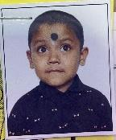
2 | Priyanshi Barman | Nursery | Parikshit Barman | Vill: Gatanga  P.O:Rangagara  782140 | SC | 8486183873 | 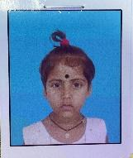
3 | Priyanshi Rabha | Nursery | Sumit Rabha | Vill:Samaguri grant  P.O: Samaguri  782140 | ST | 6002272095 | 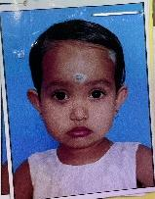
4 | Srabontika Das | Nursery | Ratan Das | Vill: Hahchara  P.O: Samaguri  782140 | SC | 8754369926 | 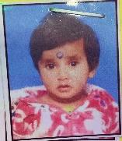
5 | Dhanip Das | Nursery | Babul Das | Vill: Gatanga  P.O:Rangagara  782140 | ----------- | 9365530516 | 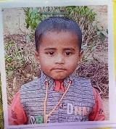
6 | Diksha Das | Nursery | Kartik Ch. Das | Vill: Chakitup  P.O: Chakitup  782140 | SC | 9365004167 | 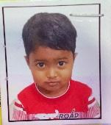
7 | Ayaan Borah | Nursery | Baikuntha Borah | Vill:Brahmachari Satra  P.O:Bheleuguri  782140 | General | 6002755215 | 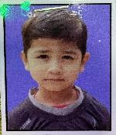
8 | Sumit Das | Nursery | Sanjay Kr. Das | Vill: Gatanga  P.O: Rangagara  782140 | ----------- | 9508763264 | 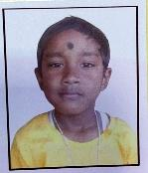
9 | Rittika Das | Nursery | Ratan Kr. Das | Vill: Gatanga  P.O: Rangagara  782140 | ----------- | 9101308311 | 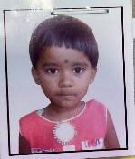
10 | Biraj Das | Nursery | Ranjit Ch. Das | Vill: Gatanga  P.O: Rangagara  782140 | ----------- | 9101033887 | 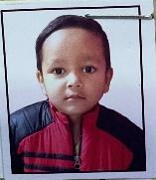
11 | Sarakshi Das | Nursery | Pranab Das | Vill: Rangagara  P.O: Rangagara  782140 | ----------- | 9864782773 | 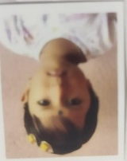
12 | Nikita Basfor | Class I | Mohan Basfor | Vill: Samaguri  P.O: Samaguri  782140 | SC | 9954729358 | 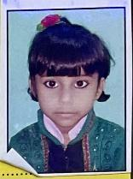
13 | Sudip Das | Class I | Supriya Das | Vill: Gatanga  P.O: Rangagara  782140 | SC | 9101081583 | 
14 | Moupriya Choudhury | Class I | Nitul Choudhury | Vill: Baraligaon  P.O:Samaguri,  782140 | General | 9678847353 | 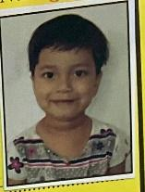
15 | Romon Orang | Class I | Mahesh Orang | Vill: Amguri, PO: Samaguri, 782140 | ----------- | 8473969583 | 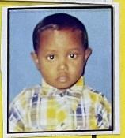
16 | Abhijit Bormon | Class I | Lt. Ranjit Bormon | Vill- Gatanga, PO- Rangagara, 782140 | ----------- | 9864912914 | 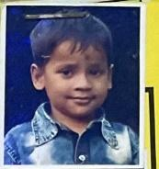
17 | Sabujdip Das | Class I | Samir Das | Vill:Kanuwamari, PO- Mowamari,  782140 | SC | 8638462939 | 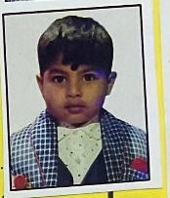
18 | Divyanka Bharati | Class I | Bishnu Prashad | Vill- Amoni, PO- Amoni, 782138 | OBC | 8638558097 | 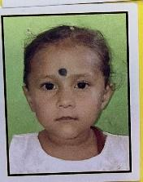
19 | Trishna Barman | Class I | Raju Barman | Vill- Samaguri Grant, PO- Samaguri, 782140 | SC | 6000025174 | 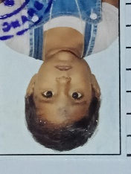
20 | Diplina Ray | Class I | Mukesh Ray | Vill- Hahchara Boraligaon, PO- Samaguri, 782140 | SC | 9678349082 | 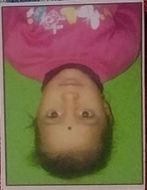
21 | Swapnil Saaz Borah | Class I | Sagar Borah | Vill: Phukontal  P.O: Samaguri  782140 | General | 8471819809 | 